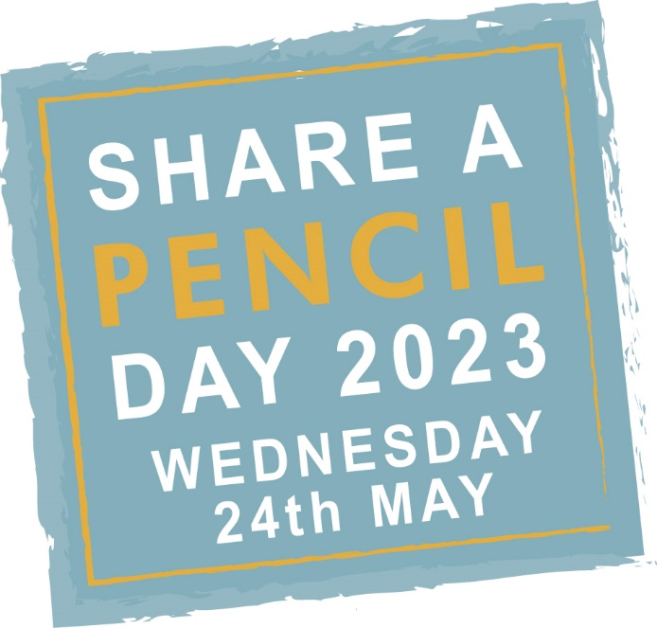

Share a Pencil Day 2023: Teachers Notes
Share a Pencil Day is split in to 3 main areas; the Introduction, the Global Education Lesson and the Poster Design Competition.
This year we have two different lesson plans, one for KS1 and a second for KS2 focusing on Children on the Move or Displaced children.
The Introduction.
Generally best done at the start of the day or on the day before, the introduction is an overview of the day briefly covering why millions of children globally are still unable to access an education, what’s involved in the day and why your school is taking part?
Materials available include an assembly style PowerPoint presentation (with notes) and short animated film.
Notes: Be sure the PowerPoint projection apparatus is working and the film can be streamed directly from the internet or is downloaded before-hand, sound is necessary for the short film.
Global Education Lesson KS1.
The KS1 lesson remains the same each year as a gentle introduction for young pupils to a very powerful subject. The KS1 lesson includes 4 case studies of children from various parts of the world who for different reasons cannot go to school. The 4 case studies cover teenage marriage, extreme poverty (having to go to work), war and conflict (refugee children on the move) and natural disasters.
The 4 case studies come with an easy to use table that pupils are asked to fill in about the 4 different scenarios they have covered. For younger age groups the class can be split in 2 or 4 with pupils studying just one or two scenarios and then discussing all 4 as a group, discovering what each other have learned.
Materials available include: the 4 case studies and templates to be filled out. Downloadable in A4 format.
Note: it is during this lesson that children are asked to share a pencil, one between two, to see what it is like to go to school without all the materials we take for granted. See General Notes below for more guidance.
Global Education Lesson Additional Tasks.
The additional tasks allows teachers and pupils to discuss the topic in other areas and in more depth, while we do retain Sharing Tasks to enable all pupils to share pencils and appreciate the lack of resources many children worldwide experience daily it is a more discursive opportunity.
See Additional Tasks section of website
Poster Design Competition KS1 (and KS2 optional).
The Poster Design Competition entitled “I love school because…” is a chance for children to think about all the good things going to school means. Children often forget school is about meeting friends, playing games, art and craft, music and socializing, even great teachers and teaching, to mention just a few benefits. Reflecting on the positive elements of school is important; it helps children understand why those missing out on school are missing out on more than just homework and times tables, and that it’s of fundamental importance in a child’s life chances. They are in fact the lucky ones for having the chance to go to a good school.
Materials available include the poster template for each child to use. Downloadable in A4 format.
Notes: If time permits this may be done at the end of the Global Education Lesson but more likely in a separate lesson or as homework. Encourage children to think of more than one thing when they design their poster. The poster element and photos of the posters designed is great for social media if you are posting about the day or lining the corridors and pin boards around school.
General Notes:
The day is about empathising with others as much as raising awareness of global education issues, learning to share and work with classmates is an integral part of the day, hence the share a pencil element. Last year one teacher complained all her pupils had snapped their pencils in two and half the class were causing a riot while the other half did their assignments, this of course is not how it should be taught. The whole class should be engaged together, sharing resources and learning in pairs, groups or as a whole. It should be engaging and interactive while age appropriate.
Social Media:
We would love to see and hear about your day as would all the other schools involved in the day. Please tag us in on your posts @ventforchange and please use the hashtags #ventforchange and #shareapencilday
For all the resources and to find out more please visit www.shareapencilday.co.uk

